# Convention

## 字体？

十号Calibri

## 什么时候需要引用文献？

1. 有数据 (Quantitative information)，如： 75% 玩家为generation Z
2. 有结论性陈述 (Qualitative information) ， 如： 主机游戏对Z世代的吸引力在逐渐增大

**绝对不能直接复制粘贴文献中的图表 ！！ 文献中的非核心数据不需要提及，只需要引用！**

## 本manuscript中的文献引用 convention:

[REF]: 此处有文献需要引用，链接已经添加在脚注

**[REF]**: 此处有文献需要引用，链接未添加在脚注或需要自行查找

**[REF]**: 此处有文献需要引用，未找到文献 ，需要寻找有相关数据的文献填入（数据留空）

**<DATA>:** 需要查找该数据，或需要从引用的相关文献中填入

# 核心思路

定义估算方式，定义“对Z世代用户吸引程度” (Target Group Index_Z) (TIGZ)，对数据进行建模 （本质上是， Z世代用户在总用户中的占比除以Z世代在总人口的占比，忽略accessibility，可以在study limitation中提及模型缺陷，体积实际TIGZ会比模型估算高（underascertainment））

在下文中，对以下数据进行对比

1. 该品类的用户数量
2. 该品类的利润
3. 该品类中主要游戏的competitive advantage (如， 腾讯游戏借助微信，QQ引流，提高游戏社交属性)
4. **该品类的TIGZ （讨论该类别对年轻人的吸引程度），在discussion中进行与其他品类横向对比**
5. **该品类中主要游戏的TIGZ（讨论该公司主要product对年轻人的吸引程度），在result中与同品类竞争公司纵向对比**

## 图表维度：

**能用图，就不用表；一个图可以包含多个子图， 尽量做到一个section只有一个图**

在每个section结束前，对 user percentage(X轴)， market share(y轴)，TIGZ（bubble大小） 画bubble plot， 并对每个公司的performance进行横向对比

在discussion中对所有品类画总bubble plot，定义cluster1,2,3 用颜色区分品类

# Academic Writing Handbook

<https://www.lshtm.ac.uk/sites/default/files/academicwritinghandbook.pdf>

正文

# 引文

We studied qualitative and quantitative traits of some major brands in their major entertainment categories. For the ease of presentation,

Due to the relatively strong competition in <field>, we performed

To help analyze the consumption preferences of generation Z, we defined the following

# Data acquisition and calibration

数据进行矫正， 使用百度index <https://index.baidu.com/v2/index.html#/>

We augmented the data set to normalize the data into desired age bands. We assumed the age distribution to be a continuous function which can be approximated using differences of gaussian algorithm. With the mathematical equation,

|  |  |  |
| --- | --- | --- |
|  |  | (1) |

Where denotes the expected age of the population, denotes to the set of the raw age distribution with 10-years age band, denotes to two constants, is a tuple with the median age and percent population at 1st and 2nd entry, respectively. The R code realization is on GitHub **(Supplementary Material)**.

We can then calculate the s===

# 3.1 Online Gaming （在线多人游戏）

## 核心思路

研究对象：

选取每个种类中 占比前三的游戏

种类:

1. MOBA
2. ARPG
3. FPS
4. RTS (Real-time strategy)
5. TBRPG (Turn-based RPG)

总样本量：15

（为什么不选用公司？因为不同公司旗下的游戏品类有区别 ，且组成成分有区别(i.e, 腾讯旗下更多的有Moba及射击游戏； 网易旗下更多二次元游戏)）。

**本section核心数据**

1. **玩家最多，5.31亿[i]**
2. **收入最高，占比75-76% [REF]**
3. **Z世代占比高，高达32.1% [ii]**
4. **…**

[**https://www.zhihu.com/question/372246459/answer/1036153927**](https://www.zhihu.com/question/372246459/answer/1036153927)

**Hypothesis:**

1. Z世代玩家对 xx (如，RTS实时策略， RPG角色扮演) 品类的游戏更感兴趣
2. **Z世代玩家对游戏的社交属性更为看重；同品类游戏中，腾讯开发的游戏更受欢迎**
3. **某些游戏属性（如，抽卡，对抗， 单机**
4. **一个受Z世代玩家欢迎的游戏，应该具有XXX, … 特点**

核心文献：

<https://pdf.dfcfw.com/pdf/H3_AP202104011480001095_1.pdf?1617264409000.pdf>

<https://www.qianzhan.com/analyst/detail/220/210708-e646b50f.html>

<https://x.qianzhan.com/xcharts/?k=%e7%a7%bb%e5%8a%a8%e6%b8%b8%e6%88%8f>

<https://zhuanlan.zhihu.com/p/446508954>

整个表不在正文出现，要放到supplementary material里，数据要画成图放到figure 1 里去

Mobile gaming is the most popular way of entertainment in all the gaming categories in 2020. With 531 million players, composed of 59.0% of the mobile device user in China [REF].[1] Mobile gaming shares **<DATA>%** of the total income of the gaming market **[REF].**

Age distribution of Chinese mobile game user[2]

决战平安京，王者荣耀年龄分布[3]

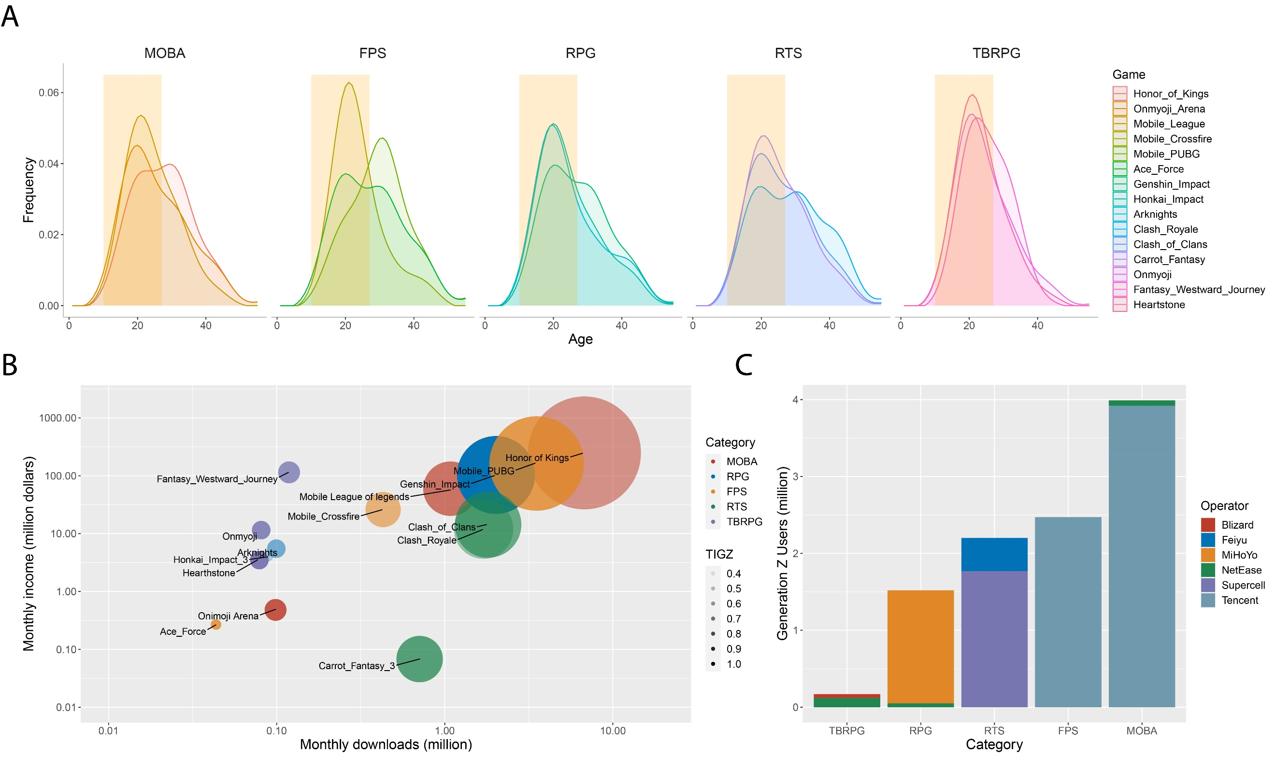

**Figure 3. a). Calibrated age distribution of user of fifteen games by categories. The shadowed orange area indicates generation Z (age 12-25).[4] b). Number of Gen-Z users of the fifteen games. The x,y axis respectively represents the number of monthly downloads from app store and the monthly income of the games from Appstore. The size of the circles indicates the number of Gen-Z users, and the transparency indicates TIGZ of each game. The x and y axis are on logarithmic scale. c). Relative popularity of the game amongst Gen-Z users in the three most popular games in each of the categories. Different color indicates different game operators.**

## 3.1.1 Market share

We picked three most popular mobile games from five categories, MOBA, FPS, RTS, RPG, TBRPG in China. We found MOBA to be the most popular genre of mobile games. All the games are free to download with in-game purchase. We used the total number of GENZ and TGIZ to evaluate preference of GENZ users.

**按照类别讲一下趋势，按照公司讲一下趋势，讲一下每个类别里最受欢迎的游戏**。

MOBA games have the highest total number of generation-Z users, but with a lower TIGZ.

**[公司趋势]**

**MOBA game is the most popular regardless of age**

The fifteen games were developed by six different companies, the market share of each company varies depending on the genre. [**Discussion里 说一下，可能是因为FPS，MOBA具有社交属性，腾讯系游戏具有微信，QQ登陆的**]

[分析用户是否可能对开发公司有粘性]

**Five genre was dominated by four companies**

**RPG Game is the more attractive to GENZ than other population**

RPG and TBRPG games, despite being the least popular genres amongst the five, has the highest weighted TIGZ of 3.20 and 3.15.

## 3.1.2 TIGZ

## 3.1.3 Product and marketing

# 3.2 B2P (PC)Game（买断制游戏）

## 3.2.1 Market share

## 3.2.2 TIGZ

## 3.2.3 Product and marketing

Discussion

We believe there is underascertainment of the size of Gen-Z user.

Supplementary Materials

We set the regression model with the following parameters. The value of each game is given in the same order as the order in the previous discussions. A single figure will be given if all the game in this categories was given the same parameter. The R-code realization is available.[5]

**Table S1. Parameters for regression model**

|  |  |  |
| --- | --- | --- |
| Parameter | Value | Comment |
| for MOBA games | (0.009, 0.0065, 0.0072) | The minimum value to maintain the trend of the distribution |
| for MOBA games |  | Did not use |
| for ARPG games |  |  |
| for ARPG games |  |  |
|  |  |  |
|  |  |  |
|  |  |  |
|  |  |  |
|  |  |  |
|  |  |  |
|  |  |  |

**Table S2. Market share by game categories[6]**

|  |  |  |
| --- | --- | --- |
| Game Type | Market Share | TIGZ |
| ARPG | 0.196 | **<DATA>** |
| MOBA | 0.150 | **<DATA>** |
| FPS | 0.141 | **<DATA>** |
| TBRPG | 0.118 | **<DATA>** |
| RTS | 0.100 | **<DATA>** |
| Others | 0.295 | **<DATA>** |

**Table S3. Characteristic of the three games with highest prevalence by category**

|  |  |  |  |  |  |  |
| --- | --- | --- | --- | --- | --- | --- |
| **Game Name** | **Category** | **Operator** | **Active player** | **Gen_z ratio** | **TIGZ** | **Comments** |
| Honor of Kings | MOBA | Tencent |  | 0.42 |  |  |
| Mobile League of legends | MOBA | Tencent |  | 0.51 |  |  |
| Onimoji Arena | MOBA | NetEase |  | 0.57 |  |  |
| Genshin Impact | ARPG | MiHoYo |  | 0.64 |  |  |
| Honkai_Impact | ARPG | MiHoYo |  | 0.31 |  |  |
| Princess_Connect | ARPG | Cygames |  | 0.43 |  |  |
| Mobile_Crossfire | FPS | Tencent |  | 0.45 |  |  |
| Mobile_PUBG | FPS | Tencent |  | 0.57 |  |  |
| Ace_Force | FPS | Tencent |  | 0.61 |  |  |
| Clash_Royale | RTS | Supercell |  | 0.40 |  |  |
| Clash_of_Clans | RTS | Supercell |  | 0.49 |  |  |
| Carrot_Fantasy | RTS | Feiyu |  | 0.53 |  |  |
| Onmyoji | TBRGB | NetEase |  | 0.58 |  |  |
| Fantasy_Westward_Journey | TBRGB | NetEase |  | 0.53 |  |  |
| HeartStone | TBRGB | Blizard |  | 0.51 |  |  |

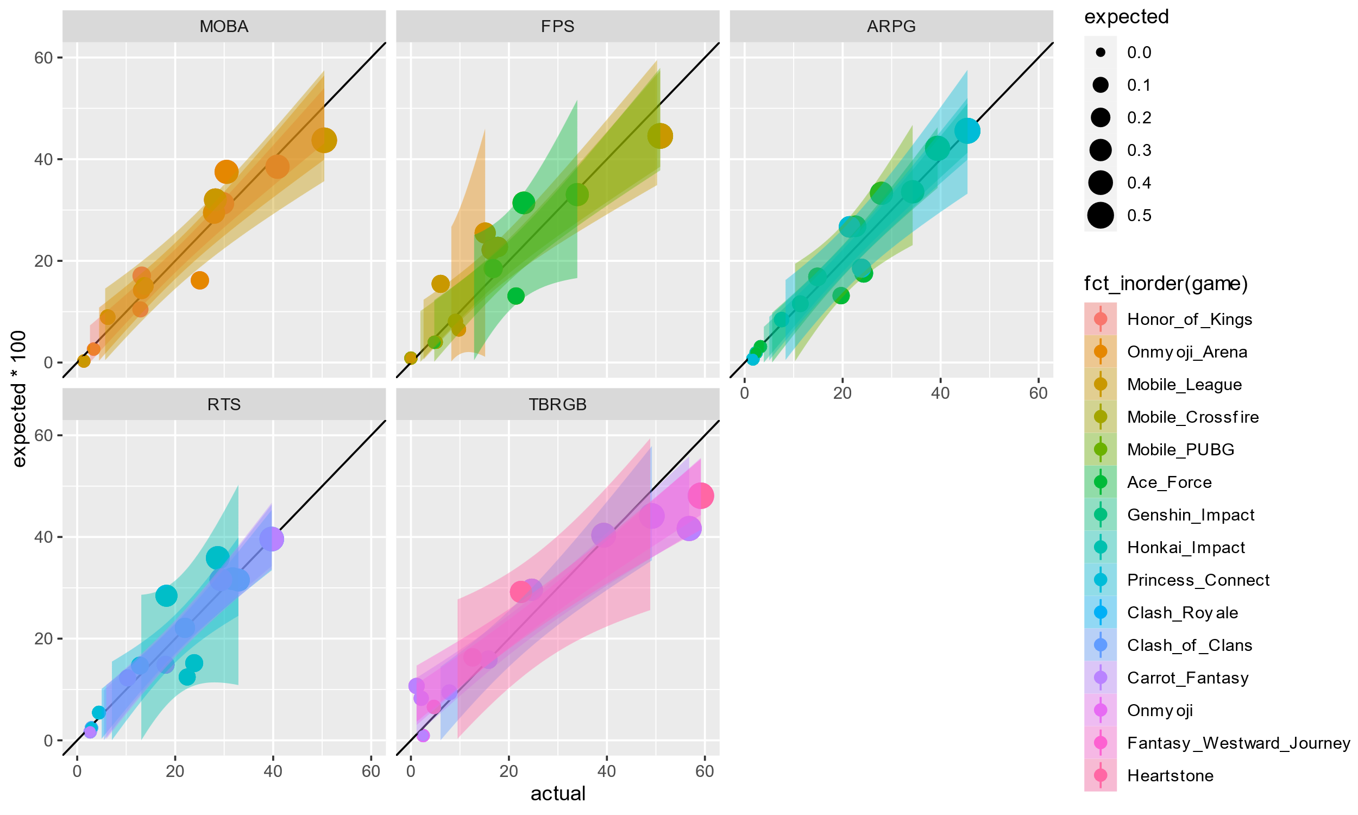

**Figure S1. Model robustness check**

References

1. http://www.cac.gov.cn/2020-04/27/c_1589535470378587.htm
2. https://www.statista.com/aboutus/our-research-commitment/2231/lai-lin-thomala
3. https://zhuanlan.zhihu.com/p/34303503
4. https://asotools.io/cn
5. https://github.com/blairyeung/KPMG-Contest
6. <https://zhuanlan.zhihu.com/p/446508954>